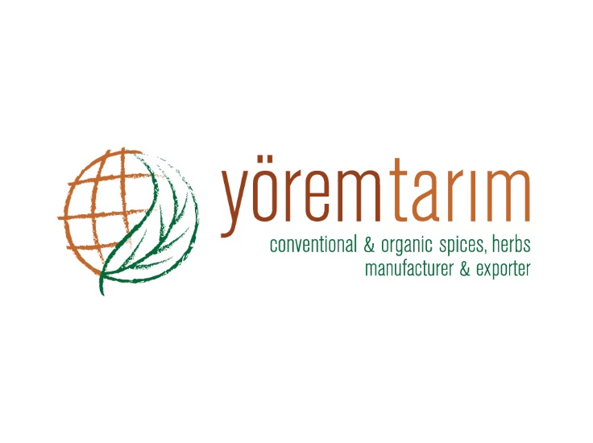 |  | DECLARATION OF PRODUCT
Product characteristics | PRODUCT
 | TURKISH CUMIN SEEDS
Botanical name | Cuminum Cyminum L.
Description | Seeds from the culture plant, belonging to the family “Cuminum Cyminum Linnaeus”
Aspect | Whole.
Appearance | Characteristic, clean.
Odour | Typical of cumin, strong.
Flavour | Characteristic, strong aromatic.
Physical analysis | Characteristic, from light to dark brown.
Microbiological analysis | No microbiological limits can be guaranteed, unless the material is treated by microbiological reduction process, because it is a natural product.
Chemical analysis | Moisture 8,0 % (Max)
 | Volatile oil 1,0 % (Min.)
 | Ash 10 % (Max.)
 | Acid insoluble ash 1 % (Max.)
Foreign matter | Absent
Extraneous matter | 1,0 %
Preservative material | Not present.
Bulk density | According to buyer’s demand.
Packing | 25 Kg net paper or nylon bags.
Storage and shelf life | Storage and shelf life for all products is minimum 24 months, when stored in cool and dry conditions away from direct sunlight.

