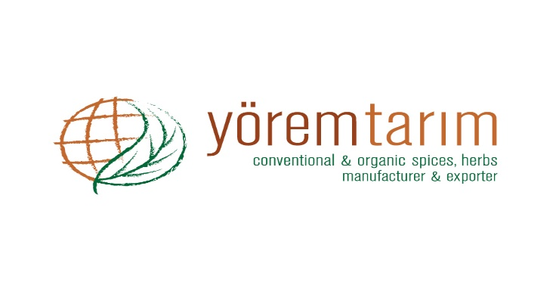 |  | DECLARATION OF PRODUCT
Product characteristics | PRODUCT
 | Laurel Leaves Cut (2-5 cm.)
Botanical name | Laurus nobilis L.
Physical analysis | Green colors, fragrant aroma, strong aromatic.  2-5 cm. +/- 15 % (Max.)
Microbiological analysis | No microbiological limits can be guaranteed, unless the material is treated by microbiological reduction process, because it is a natural product.
Chemical analysis | Moisture 10 % (Max.)
 | Volatile oil 1 % (Min.)
 | Ash 5 % (Max.)
 | Acid insoluble ash 1 % (Max.)
Preservative material | Not present.
Packing | 25 kg nylon bags.
Storage and shelf life | Storage and shelf life for all products is minimum 24 months, when stored in cool and dry conditions away from direct sunlight.
Shipping of products | Depends on request.
Country of origin | TURKEY

