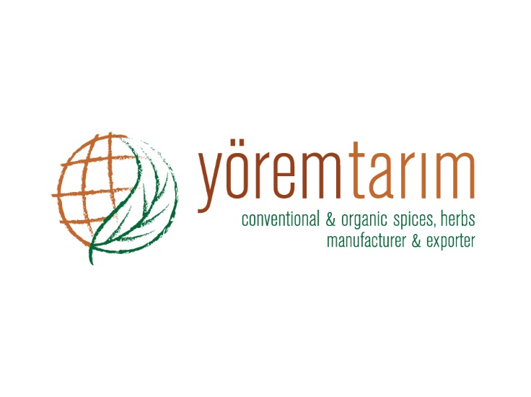 |  |  | DECLARATION OF PRODUCT
Product characteristics | PRODUCT
 | Laurel Leaves FAQ Pressed In Bales
Botanical name | Laurus nobilis L.
Physical analysis | Green colors, fragrant aroma, strong aromatic.
 | Whole leaves 10-15 % | Insect defilled 15 % (Max.)
 | Below 6 mm 10 % (Max.) | Black and brown spot 20 % (Max.)
 | Stems 5-7 % | Webbed leaf 8 % (Max.)
 | Hard&Soft damage 70-80 %
Microbiological analysis | No microbiological limits can be guaranteed, unless the material is treated by microbiological reduction process, because it is a natural product.
Chemical analysis | Moisture 10 % (Max.)
 | Volatile oil 1 % (Min.)
 | Ash 5 % (Max.)
 | Acid insoluble ash 1 % (Max.)
Preservative material | Not present.
Packing | 25-50 kg. Jute or nylon bales.
Storage and shelf life | Storage and shelf life for all products is minimum 24 months, when stored in cool and dry conditions away from direct sunlight.
Shipping of products | Depends on request.
Country of origin | TURKEY

