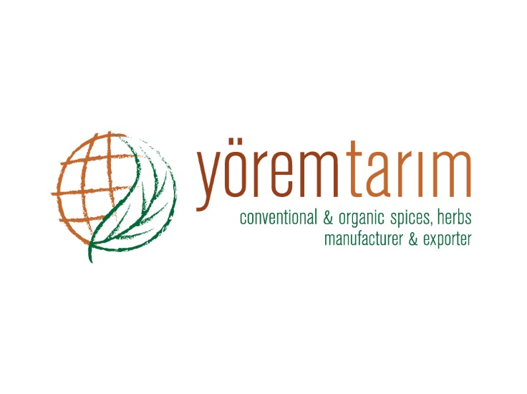 |  |  | DECLARATION OF PRODUCT
Product characteristics | PRODUCT
 | Laurel Leaves Hand Pick Select (5-10 cm.)
Botanical name | Laurus nobilis L.
Physical analysis | Green colors, fragrant aroma, strong aromatic. |  |  | Between 5-10 cm.: 75 % (Min)  Below 5 cm.: 5 % (Max )  Above 10 cm.: 20 % (Max)
 | Whole leaves 94 % (Max.) | Insect defilled 2 % (Max.)
 | Black spot 2 % (Max.) | Leaf with holes 2 % (Max.)
 | Brown spot 5 % (Max.) | Webbed leaf 2 % (Max.)
 | Broken leaves 6 % (Max.) | Stems 0,5 % (Max.)
Microbiological analysis | No microbiological limits can be guaranteed, unless the material is treated by microbiological reduction process, because it is a natural product.
Chemical analysis | Moisture 10 % (Max.)
 | Volatile oil 1 % (Min.)
 | Ash 5 % (Max.)
 | Acid insoluble ash 1 % (Max.)
Preservative material | Not present.
Packing | 10 kg cartons.
Storage and shelf life | Storage and shelf life for all products is minimum 24 months, when stored in cool and dry conditions away from direct sunlight.
Shipping of products | Depends on request.
Country of origin | TURKEY

