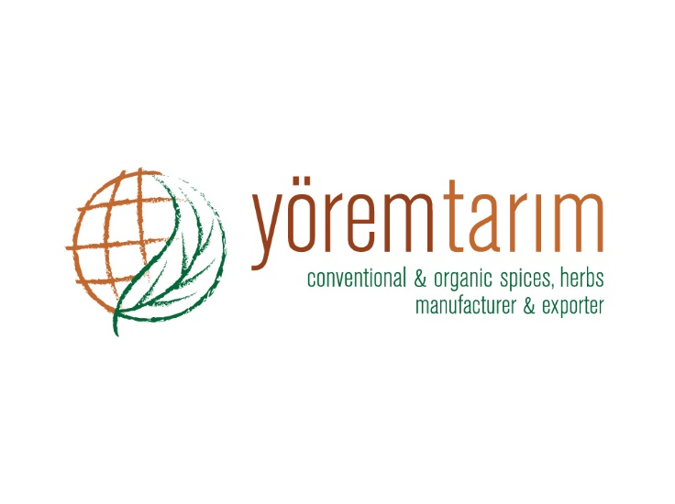 |  | DECLARATION OF PRODUCT
Product characteristics | PRODUCT
 | Sage Rubbed Extra
Botanical name | Salvia triloba
Physical analysis | Like green and greenish brown characteristics to that grown in Turkey, or aromatic lingering flavour. |  | Below 3500 micron 95 % (Min.)  Below 500 micron 5 % (Max.)
Microbiological analysis | No microbiological limits can be guaranteed, unless the material is treated by microbiological reduction process, because it is a natural product.
Chemical analysis | Moisture 12 % (Max.)
 | Volatile oil 1,5 % (Min.)
 | Ash 10 % (Max.)
 | Acid insoluble ash 1 % (Max.)
Preservative material | Not present.
Packing | 10 kg kraft paper.
Storage and shelf life | Storage and shelf life for all products is minimum 24 months, when stored in cool and dry conditions away from direct sunlight.
Shipping of products | Depends on request.
Country of origin | TURKEY

